**Problem assignment 1**

*Due: Wednesday, September 11, 2019*

**Problem 1. Map coloring problem**

**Part a.**

Initial state: A map with no color painted on.

Operators: Valid paint steps

Goal condition: A map colored with no countries on the map that share a border are assigned the same color.

**Part b.**

The search space can be defined as all valid configurations of paint to the map.

The upper estimate bound for the search space size is the number of countries times color choice; In this case, it’s at most 9*3=27.

**Part c.**

Considering the abstraction of the spatial layout, the problem can be formulated to another search problem: Divide the set of nodes in to three independent subsets(green red blue). In each subsets, the nodes are nonadjacent.

In this way, the formulation can be defined as:

Initial state: A set with all nodes

Operations: Divide each node into three subsets based on the nonadjacent rule,

Goal condition: three well divided independent subsets.

The search space size is the size of the original sets of nodes, 9. This is a more advantageous formulation.

**Part d.**

One possible solution for the problem.

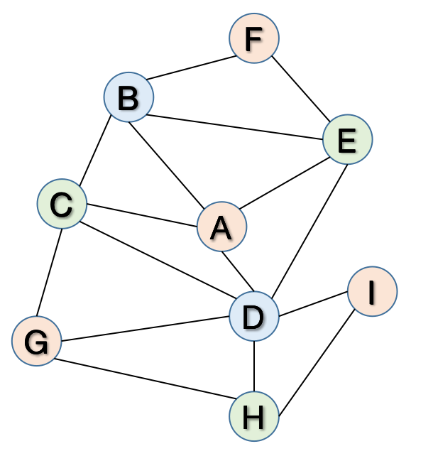

**Problem 2. Traveler problem**

**Part a.**

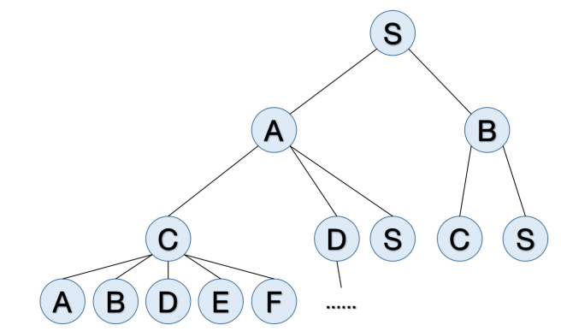

The expanded order would be S-A-B-C-D-S-C-S-A-B-D-E-F-...

**Part b.**

If using the depth-first search, with the elimination of cyclic, the route could be S-A-C-E-G.

**Part c.**

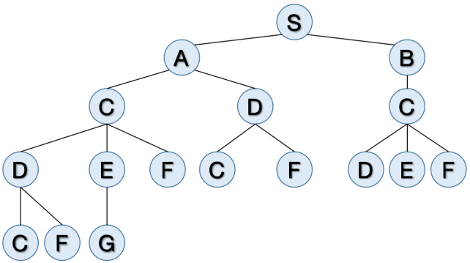

The expand step of the BFS that prevents cyclic would be:

S-A-B-C-D-C-D-E-F-C-F-D-E-F-C-F-G

And the searched route would be S-A-C-E-G.

**Part d.**

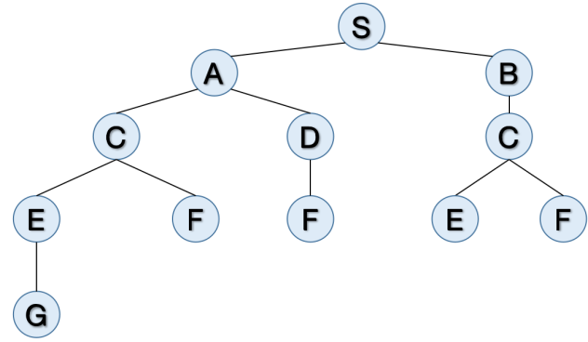

The expand step of BFS that checks all state repeats would be:

S-A-B-C-D-C-E-F-F-E-F-G

And the searched route would be S-A-C-E-G.

**Problem 3. A problem-solving agent for the 8-puzzle problem**

**Part a .** See bfs.py

**Part b.** See bfs_stats.py

**Part c.** See bfs_cycles.py

**Part d.** See bfs_repeats.py

**Part e.**

Vanilla BFS search:

|  |  |  |  |  |
| --- | --- | --- | --- | --- |
|  | **Nodes generated** | **Nodes expanded** | **Maximum length of queue** | **Length of solution path** |
| **Example 1** | 82 | 29 | 53 | 4 |
| **Example 2** | 1383 | 500 | 883 | 7 |
| **Example 3** | 5623 | 1962 | 3661 | 9 |
| **Example 4** | 87543 | 31658 | 55885 | 11 |

BFS search with the elimination of cyclic state repeats.

|  |  |  |  |  |
| --- | --- | --- | --- | --- |
|  | **Nodes generated** | **Nodes expanded** | **Maximum length of queue** | **Length of solution path** |
| **Example 1** | 45 | 16 | 22 | 4 |
| **Example 2** | 235 | 84 | 105 | 7 |
| **Example 3** | 501 | 176 | 226 | 9 |
| **Example 4** | 2199 | 808 | 934 | 11 |
| **Example 5** | 160639 | 59524 | 67175 | 19 |

BFS search with the elimination of all state repeats.

|  |  |  |  |  |
| --- | --- | --- | --- | --- |
|  | **Nodes generated** | **Nodes expanded** | **Maximum length of queue** | **Length of solution path** |
| **Example 1** | 45 | 16 | 22 | 4 |
| **Example 2** | 235 | 84 | 105 | 7 |
| **Example 3** | 491 | 173 | 216 | 9 |
| **Example 4** | 1951 | 723 | 775 | 11 |
| **Example 5** | 84813 | 31591 | 30611 | 19 |

As shown by the table above, the BFS search with the elimination of all state repeats has the best performance, then the BFS search with the elimination of cyclic state repeats. That’s because it reduces all the [redundancy](https://www.youdao.com/w/redundancy/" \l "keyfrom=E2Ctranslation) when generating a search tree. Some useless nodes don’t have to be generated several times.

**Part f.** See dfs_limit.py

Depth-limited DFS search (with depth limitation 10)

|  |  |  |  |  |
| --- | --- | --- | --- | --- |
|  | **Nodes generated** | **Nodes expanded** | **Maximum length of queue** | **Length of solution path** |
| **Example 1** | 264 | 96 | 15 | 4 |
| **Example 2** | 167 | 58 | 15 | 7 |
| **Example 3** | 1108 | 401 | 16 | 9 |

Generally, the DFS search doesn’t preformed as well as the elimination of all state repeats. That’s because it might have to go through more nodes before search out the optimal path rather than a sub-optimal. However, it performs very well at the queue length control, for it doesn’t need to expanded as many nodes as BFS search do.